HIST 381-001/581-001: Digital History
Monday and Wednesday, 3:00 – 4:15 p.m., Simplot/Micron 118

Instructor: Leslie Madsen-Brooks
E-mail: lesliemadsen-brooks@boisestate.edu
Twitter: @lesliemb
Phone: (208) 426-4035
Office: Library 183
Office hours: 1:30 to 2:50 p.m. Monday and Wednesday, and by appointment.
Course website: http://digitally.doinghistory.com

Introduction
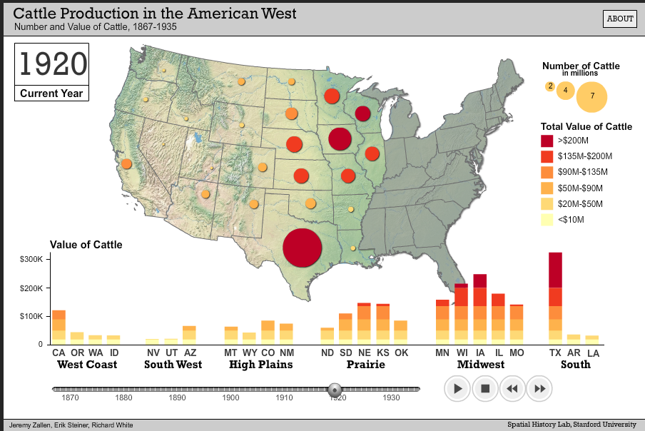
What does it look like when we take our study of the past into the digital realm? What happens, historiographically speaking, when we undertake our research and writing in an age when millions of significant primary and secondary sources—texts, photographs, videos, audio, artifacts, maps, and more—have been digitized? To what extent should it be our responsibility as historians to communicate our findings through the same digital media in which we now undertake much of our research? What stance should we take on the accessibility of data, primary sources, and academic publications? What kinds of relationships should we maintain with members of the public who are accessing many of the same sources and using them in both traditional and new ways? As we move into a digital era, what has changed about historical practice, what remains the same, and why does it matter?

Questions such as these will drive our inquiry into the historical discipline’s place in the constellation of theories and methods that have come to be known as the “digital humanities.” This course is about methods, controversies, ideas and ideologies, and the way U.S. history gets deployed in a digital age. Students should emerge from the course with a new understanding of historical practice in the 21st century. They also will have opportunities to develop skills in divergent genres of historical writing, as well as to plan for and/or implement complex projects using digital technologies.

A different kind of class
We belong on the margin---not because we've been pushed there, but because that's where the edge is. And when the center expands to swallow the periphery---not in the name of exclusivity, but in the name of incorporation and assimilation---we need to push ourselves further away. The digital humanities should not be about the digital at all. It's about innovation and disruption. The digital humanities is really an insurgent humanities.
I say embrace the circus, the fair, the freakshow. Stop worrying about definitions and categories and celebrate hybridity. Take advantange of all that the margin affords. Do what you do and keep doing what you do. Engage outsiders, build coalitions, and form tactical collaborations. And move on when the time comes to move on, finding another periphery point to innovate and disrupt.

That’s how Mark Sample has described the digital humanities; this course subscribes to that ethos. Be prepared for unfamiliar, complex, and imperfect technologies; a good deal of experimentation; working on the margins of mainstream academic humanities practice; and occasional failure (from which we will learn and move forward). While we will read and discuss texts similar to those you may have read in other history courses, students in History 381/581 can expect to perform different kinds of work in this course. We will plan a research paper so that we can get a sense of the opportunities and limitations of digital sources, yet I am replacing most of the traditional history coursework with a collaborative, project-driven approach that still emphasizes research, writing, and revision, but outside the scope of an individually authored essay.

As part of our experimentation, I encourage you to bring to class any “smart” digital devices you own—smartphones, tablets, laptops, etc.—so that we may explore the ways historians and others are undertaking research and presenting history on the (sometimes very) small screen. I trust you won’t let your devices distract you from the tasks at hand.

What this means for you, the student
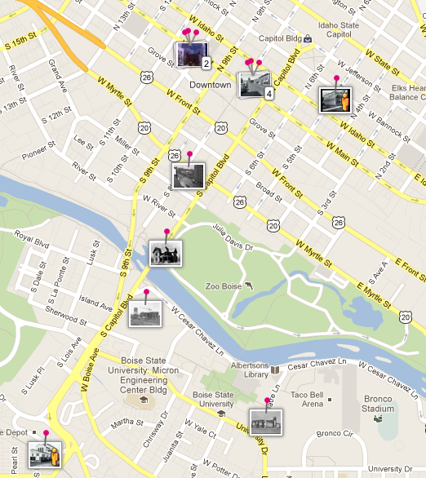
You will be asked to collaborate extensively throughout the semester. Forty percent of your grade in this course is tied directly to group work, and successful contributions to the Boise Wiki and class discussion depend on everyone participating meaningfully. If you are the kind of student who (a) tends not to show up for or contribute to group work or (b) tends to do the bulk of work in a group project, this is probably not the course for you. Students who do accept this mission to collaborate should emerge from the semester with a new set of technical skills; a new way of looking at history; and a good deal of skill in researching everyday life in the past, particularly the history of a place. Successful students will demonstrate critical and creative thinking, a dedication to detail, and an ability to think both broadly and deeply about digital tools and methodologies.

This emphasis on collaboration means you will need to choose your group members carefully. Use the first part of the semester to get to know the personalities and work habits of your fellow students. I will remind you of this during class time, but I also want to put it in writing and emphasize it here: do not form a group with the people who happen to be sitting near you. It’s a terrible way to form a successful team.

Learning goals
By the end of the course, students will be able to:
- explore and employ a variety of digital technologies useful to historians, including primary- and secondary-source databases, wikis, blogs, augmented reality, and maps.
- understand copyright, Creative Commons, and the public domain, and use, create, and share resources/intellectual property appropriately.
- explain the democratizing possibilities of digital tools for historical practice, and understand and use these tools toward achieving these ends.

Learning activities
In this course, students will:

- locate and evaluate primary-source databases, either through the library, government, private foundations, or for-profit companies (through free trials).
- explore and discuss the technologies currently in use by museum professionals, historic preservationists, digital humanists, and others.
- practice finding, crediting, repurposing, synthesizing, and reinterpreting local resources
- consider the advantages and liabilities of “big data” to historians’ work.
- consider how to go about learning a programming language, how to select a language, whether their own investment in learning a programming language might pay off, and if so, in what ways.

Assessment and Grade Distribution
Students will be evaluated formally on the following assignments and activities:

UNDERGRADUATES (HIST 381)

- report on an interview with a practicing digital humanist (15%)
- a research project plan that relies on digitized primary sources (20%)
- contributions to the Central Rim neighborhood project (group project - 30%)
- grant proposal (undergrad-only group project - 25%)
- participation in small- and large-group discussion during class meetings (10%)

GRADUATE STUDENTS (HIST 581)

- report on an interview with a practicing digital humanist (15%)
- a research project plan that relies on digitized primary sources (15%)
- NEH grant proposal for a project based on “big data” or GIS data (grad-only group project - 20%)
- contributions to the Central Rim neighborhood project (group project - 30%)
- Employment + technology plan (10%)
- participation in small- and large-group discussion during class meetings (10%)

Course materials (available at the campus bookstore and at online booksellers)
- Jack Doherty and Kristen Nawrotzki. Writing History in the Digital Age. 2012. Available for free at http://writinghistory.trincoll.edu/.
- Bryan Alexander. The New Digital Storytelling. Santa Barbara: Praeger, 2011.
- Chris Wilson and Paul Groth, eds. Everyday America: Cultural Landscape Studies After J. B. Jackson. Berkeley: University of California Press, 2003.

Participation
The day-to-day requirements of this class are simple: do the required reading, reflect on it, and come to class prepared to engage in thoughtful discussion. (I promise to do the same.)

Your presence in class is very important. Participation in course discussions and in-class small group work constitutes a significant portion of your grade (10%). To receive an A for your participation, you must participate meaningfully in class just about every day. Merely attending class will earn you a C- for participation.

Writing
The quality of your writing—both its clarity and the depth of thought expressed in it—contributes significantly to your final grade in this course. It is imperative, then, that you schedule sufficient time to do the reading required for each assignment, write a solid first draft, and revise it. It is important, too, that you use the appropriate voice for each different genre of writing in this course: project proposals, wiki articles, research papers, and more. For each project, I expect you to undertake several revisions. I recommend you form a writing group with students outside your group to swap assignments and get their feedback on your group’s work, as well as on your individual work.

Because of the number of students in my courses, I can’t review entire drafts of your assignments. That said, I’m happy to look over your proposed thesis statement, an outline, and a paragraph or two that you’re finding troublesome. Please do come see me for help with your assignments, as there won’t be opportunities to rewrite them for better grades.

Late assignment policy
In the historical professions, deadlines matter. Exhibitions must open on time. Grant proposal deadlines aren’t negotiable. Collaborative public history endeavors—like building digital tools and organizing festivals—require everyone to contribute in a timely manner so that work may proceed on schedule. The same holds true for this class. Assignments must be turned in at the beginning of class on the day they are due. Late assignments will be penalized 1/3 of a grade (e.g. a B becomes a B-) after the beginning of class, and I will deduct an additional 1/3 grade for each 24 hours that pass before you turn in the paper.

That said, I’m not heartless. If you have an emergency and anticipate not being able to turn in your paper on time, come see me and we’ll see if we can work something out.

Please note: Technological failure does not constitute an emergency. Hard drives fail, servers go down, file transfers time out, and files get corrupted. You must plan for such contingencies: keep backups of your files, have extra ink cartridges handy, know where the local wifi hotspots are in case your home internet connection goes down. Technological issues are not excuses for late work. Please protect yourself (and your grades) by managing your time and backing up your work.

Extra credit opportunity
There will be one opportunity for extra credit this semester:

- Register, attend, and reflect upon (in writing) Boise State’s 2014 THATCamp (it takes place September 13): http://boisestate2014.thatcamp.org/register/.

Participation allows you to raise your course grade by as much as 5%. You will receive more details on this opportunity early in the course.

Plagiarism
A student commits plagiarism not only if she turns in someone else’s work as her own, but also if she borrows others’ ideas or phrases without giving them credit. We can discuss this in class if anyone has any questions. Any student who plagiarizes or cheats on any assignment may receive an F on the assignment or in the course and may be subject to academic discipline by the university.

I am interested in your thoughts and your creative and analytical work. Please share them with me!

Accommodations
I need to hear from anyone who has a disability that may require some modification of seating, assignments, or other class requirements so that appropriate arrangements may be made. Please see me after class or during my office hours. (You will also need to contact the Disability Resource Center at 208-426-1583 located in the Administration Building, room 114 to meet with a specialist and coordinate reasonable accommodations for any documented disability. For more information on BSU Disability Resource Center (DRC) see the web site at http://drc.boisestate.edu/)

Our classroom weapons policy
In spring 2014, the Idaho state legislature voted to allow some people to bring guns onto college campuses, including into classrooms. I encourage all students to read the campus’s updated policy on firearms and weapons at http://policy.boisestate.edu/campus-security-and-safety/firearms-weapons-possession/.

You should also know that I am profoundly uncomfortable with the presence of weapons in the classroom, and I would appreciate it if students would not bring them to our class. Why? Because a gun represents to me the threat of violence, and thus the potential or implied presence of a weapon will change the way I teach and interact with students. Other students have let me know they do not feel as comfortable talking openly in the classroom knowing that guns have been welcomed onto campus.

I have crafted the following classroom policy on firearms in consultation with campus administrators knowledgeable about student safety, campus policy, and state law.

- If you are a qualified retired law enforcement officer or someone who holds an enhanced license to carry concealed weapons, you are legally permitted to bring your concealed weapon into the classroom.

- If I see a weapon in the classroom, even if it is exposed unintentionally, that weapon is no longer concealed. I will leave the classroom and call the police, and you will be asked to leave class for the day.

- If you view a weapon in this classroom and it makes you uncomfortable, please report it to me and leave the classroom. I will notify the police.
If the reasons for this classroom policy are not clear to you, I am happy to explain them, however the policy itself is not up for debate, negotiation, or revision.

If you would like to add Boise State’s Campus Security and Police Services to your phone’s contact list, the department may be reached at (208) 426-6911.

Talk to me
I will be available during my office hours to address your concerns with the class and assignments. I encourage you to come see me if you feel you have not been offered a chance to participate in class discussion, you are troubled by a particular assignment, you would like to talk more with me about an issue raised in class, or you have concerns about your performance in the course.

Image credits:

- Screen capture of Boise, ID on HistoryPin. http://www.historypin.com/map/ - !/geo:43.600623,-116.193729/zoom:14/. Acccessed 20 August 2012.
- Screen capture of “Cattle Production in the American West” by the Stanford Spatial History Project. http://www.stanford.edu/group/spatialhistory/cgi-bin/site/viz.php?id=141&project_id=0. Accessed 20 August 2012.

COURSE SCHEDULE

Please complete each set of readings before class on the date shown.

Historians in a Digital Age

August 27: Introductions
- Job ads: http://www.museumsandtheweb.com, https://pinboard.in/u:mcburton/t:dhjob/, https://pinboard.in/u:miriamposner/t:Jobs/

August 29:

- Hitchcock, “Academic History Writing and its Disconnects”: http://journalofdigitalhumanities.org/1-1/academic-history-writing-and-its-disconnects-by-tim-hitchcock/
- Thomas, “Computing and the Historical Imagination”: http://www.digitalhumanities.org/companion/view?docId=blackwell/9781405103213/9781405103213.xml&chunk.id=ss1-2-5&toc.depth=1&toc.id=ss1-2-5&brand=9781405103213_brand
- Forster, “I’m Chris. Where am I wrong?” Read the post and the conversation in the comments: http://hastac.org/blogs/cforster/im-chris-where-am-i-wrong
- Meeks, “Digital Humanities as Thunderdome”: http://journalofdigitalhumanities.org/1-1/digital-humanities-as-thunderdome-by-elijah-meeks/
- Young Entrepreneur Council, “15 Basic Tech Skills All Entrepreneurs Should Adopt Early”: http://upmarketzine.com/2012/08/04/15-basic-tech-skills-all-entrepreneurs-should-adopt-early/

September 1: Labor Day. Class does not meet.
September 3:
- Nawrotzki and Dougherty, Writing History in the Digital Age, Introduction: http://writinghistory.trincoll.edu/introduction-2012-spring/
- Tanaka, Writing History in the Digital Age, “Pasts in a Digital Age”: http://writinghistory.trincoll.edu/revisioning/tanaka-2012-spring/
- Cebula, “An Open Letter to the Historians of the 22nd Century”: http://www.slate.com/articles/arts/culturebox/2013/07/how_will_historians_of_the_future_sort_through_the_data_glut_of_the_present.html

Place and Space

September 8: Introduction to the Central Rim neighborhood project.
- Bembeneck, “Spatial Storytelling”: http://www.playthepast.org/?p=2967
- Explore:
  - the Digital Public Library of America at http://dp.la/ and especially http://dp.la/exhibitions and http://bibliotechy.github.io/dpla/
  - the Roy Rosenzweig Center for History and New Media at http://chnm.gmu.edu/
  - DevDH.org: http://devdh.org/
  - Omeka showcase: http://omeka.org/showcase/

September 10: Selections from Everyday America:

- Henderson, “What (Else) We Talk About When We Talk About Landscape: For a Return to the Social Imagination” (178-198)
- Lewis, “The Monument and the Bungalow: The Intellectual Legacy of J. B. Jackson” (85-108)
- Clay, “Crossing the American Grain with Vesalius, Geddes, and Jackson: The Cross Section as a Learning Tool” (109-129)
- Davis, “Looking Down the Road: J. B. Jackson and the American Highway Landscape” (62-80)

September 15: Selections from Everyday America:

- Fiege, “Private Property and the Ecological Commons in the American West” (219-231)
- Sewell, “Gender, Imagination, and Experience in the Early-Twentieth-Century American Downtown” (237-254)
- Rojas, “The Enacted Environment: Examining the Streets and Yards of East Los Angeles” (275-292)

Crafting Data and Sources into Historical Narratives

September 17: The New Digital Storytelling, Introduction, Chapters 1-3 (xi-43)

September 22: The New Digital Storytelling, Chapters 4-5 (47-89)

September 24:
- The New Digital Storytelling, Chapter 11
- Digital humanist interview due.

September 29: Work day for the Central Rim neighborhood project.

Data

October 1: Big data
- Dumbill, “What is Big Data?”:
http://radar.oreilly.com/2012/01/what-is-big-data.html
- Croll, “Big Data is our generation’s civil rights issue, and we don’t know it”: http://radar.oreilly.com/2012/08/big-data-is-our-generations-civil-rights-issue-and-we-dont-know-it.html
- Bluestein, “Big Data on Campus is Like a Keg Stand for Your Brain”:
http://www.fastcompany.com/1843980/big-data-campus-keg-stand-your-brain
- Gibbs and Owen, Writing History in the Digital Age, “The Hermeneutics of Data and Historical Writing”: http://writinghistory.trincoll.edu/data/gibbs-owens-2012-spring/
- Silverman, “Through a Data Set, Darkly”: http://www.psmag.com/navigation/books-and-culture/data-set-darkly-quantitative-analysis-secret-understanding-culture-72410/

October 6: Curating and Preserving Data Digitally
- Flanders and Muñoz, What is data curation?”: http://guide.dhcuration.org/intro/
- Fenlon, Jett, and Palmer, “Digital Collections and Aggregation”: http://guide.dhcuration.org/collections/
- Grotke, “Collaborating to Identify Government or Election-Related Websites to Preserve”: http://blogs.loc.gov/digitalpreservation/2012/08/collaborating-to-identify-government-or-election-related-websites-to-preserve/
- Lavoie and Dempsey, “Thirteen Ways of Looking at. . .Digital Preservation”: http://dlib.org/dlib/july04/lavoie/07lavoie.html
- Ashenfelder, “One Family’s Personal Digital Archive Project”: http://blogs.loc.gov/digitalpreservation/2012/07/one-familys-personal-digital-archives-project/

October 8: Working with large datasets

- Owens, “Defining Data for Humanists: Text, Artifact, Information or Evidence”: http://journalofdigitalhumanities.org/1-1/defining-data-for-humanists-by-trevor-owens/
- Underwood, “Where to start with text mining”: http://tedunderwood.wordpress.com/2012/08/14/where-to-start-with-text-mining/
- Manovich, “What is visualization?” Download the essay at http://manovich.net/2010/10/25/new-article-what-is-visualization/
- Sherratt, “It’s All About the Stuff: Collections, Interfaces, Power, and People”: http://journalofdigitalhumanities.org/1-1/its-all-about-the-stuff-by-tim-sherratt/
- Collins, “Poe’s Debut, Hidden in Plain Sight?” http://www.newyorker.com/books/page-turner/poes-debut-hidden-in-plain-sight

October 13: Working with large datasets: case study from the Cooper-Hewitt National Design Museum
- Chan, “Releasing the Collection on GitHub”: http://labs.cooperhewitt.org/2012/releasing-collection-github/
- Gonzalez, “Applying Digital Humanities Approaches to Museum Collections Data”: http://desigonzalez.tumblr.com/post/67178874721/applying-digital-humanities-approaches-to-museum
- Ridge, “Mia Ridge explores the shape of Cooper-Hewitt collections”: http://labs.cooperhewitt.org/2012/exploring-shape-collections-draft/
- Walter, “People playing with collections #14: collection data on Many Eyes”: http://labs.cooperhewitt.org/2012/collection-data-eyes/
- Murray-John, “Hacking on Cooper-Hewitt's data release at THATCamp, Or, How to get me to work for free”: http://hackingthehumanities.org/post/hacking-cooper-hewitts-data-release-thatcamp-or-how-get-me-work-free

Visualization

October 15:
- Stack, “Art Maps and the museum as platform”: http://www.tate.org.uk/context-comment/blogs/art-maps-and-museum-platform
- Stack, “Tate Digital Strategy 2013-2015”: http://www.tate.org.uk/research/publications/tate-papers/tate-digital-strategy-2013-15-digital-dimension-everything

October 20:
- Theibault, Writing History in the Digital Age, “Visualizations and Historical Arguments”: http://writinghistory.trincoll.edu/evidence/theibault-2012-spring/
- Explore the Spatial History Project at http://www.stanford.edu/group/spatialhistory/cgi-bin/site/index.php — especially Shaping the West at http://www.stanford.edu/group/spatialhistory/cgi-bin/site/project.php?id=997 (scroll down to see the visualizations)

October 22: Work day for the Central Rim neighborhood project
- Research project plan due.

October 27: Work day for the Central Rim neighborhood project

Legal Issues and Access

October 29:

- Levine, “Policy, Practice, and Law”: http://guide.dhcuration.org/legal/policy/
- Read about topics of interest to you at this Copyright and Fair Use Overview: http://fairuse.stanford.edu/Copyright_and_Fair_Use_Overview/

November 3:
- “Using Works in the Public Domain”: http://www.nolo.com/legal-encyclopedia/works-public-domain-permission-29523.html
- Fitzpatrick, “Getting Permission to Publish: Ten Tips for Website Managers”: http://www.nolo.com/legal-encyclopedia/getting-permission-publish-ten-tips-29933.html

November 5: Work day for the Central Rim neighborhood project

The Public Problematic

November 10: The Wisdom (?) of Crowds
- Wolff, Writing History in the Digital Age, “The Historian’s Craft, Popular Memory, and Wikipedia”: http://writinghistory.trincoll.edu/crowdsourcing/wolff-2012-spring/
- Graham, Massie, and Feuerherm, Writing History in the Digital Age, “The HeritageCrowd Project: A Case in Crowdsourcing Public History”: http://writinghistory.trincoll.edu/public-history/graham-etal-2012-spring/
- Owens, “The Key Questions of Cultural Heritage Crowdsourcing Projects”: http://www.trevorowens.org/2012/07/the-key-questions-of-cultural-heritage-crowdsourcing-projects/
- Explore the availability of broadband internet in the U.S. (and especially Idaho) via these government maps: http://www.broadbandmap.gov/technology

November 12: Laypeople and Digital Historical Practice
- Explore the Black Confederate Soldiers site: http://www.blackconfederatesoldiers.com/
- Levin, “Black Confederate Resources”: http://cwmemory.com/book/black-confederate-resources/
- Madsen-Brooks, Writing History in the Digital Age, “‘I nevertheless am a historian’: Digital Historical Practice and Malpractice around Black Confederate Soldiers”: http://writinghistory.trincoll.edu/crowdsourcing/madsen-brooks-2012-spring/
- Explore http://lastamericanpirate.net/. SPOILER ALERT: Skip the first post; read it after you have explored the rest of the site.

Games

November 17:
- The New Digital Storytelling, Chapters 6-7 (91-122)
- Meyers, “Lessons from Assassin’s Creed for Constructing Educational Games”
http://www.playthepast.org/?p=2077
- Employment + Technology plan due (grad students only)

November 19:
- The New Digital Storytelling, Chapter 10 (151-61)
- Writing History in the Digital Age, “Pox and the City: Challenges in Writing a Digital History Game”: http://writinghistory.trincoll.edu/evidence/zucconi-etal-2012-spring/
- Sample, “Rebooting Counterfactual History with JFK: Reloaded”: http://www.playthepast.org/?p=1392
- Sample, “A Revisionist History of JFK: Reloaded”: http://www.playthepast.org/?p=1519

November 24-28: Thanksgiving break. Class does not meet.

December 1: Work day for the Central Rim neighborhood project.

December 3: Work day for the Central Rim neighborhood project.

December 8: Reflection.

- Burke, “The Humane Digital”: http://blogs.swarthmore.edu/burke/blog/2013/05/03/the-humane-digital/
- Godin, “Perhaps you could just make something awesome instead”: http://sethgodin.typepad.com/seths_blog/2013/07/perhaps-you-could-just-make-something-awesome-instead.html
- Grant proposal due.

December 10: Wrap-up and course evaluations.

Final exam (presentations): 2:30 to 4:30 p.m., Monday, December 15
- Central Rim Neighborhood Project due.

Mark Sample, comment on “I’m Chris. Where am I wrong?” HASTAC, 28 Sept. 2010, http://hastac.org/blogs/cforster/im-chris-where-am-i-wrong#comment-16481.

